Site Overview
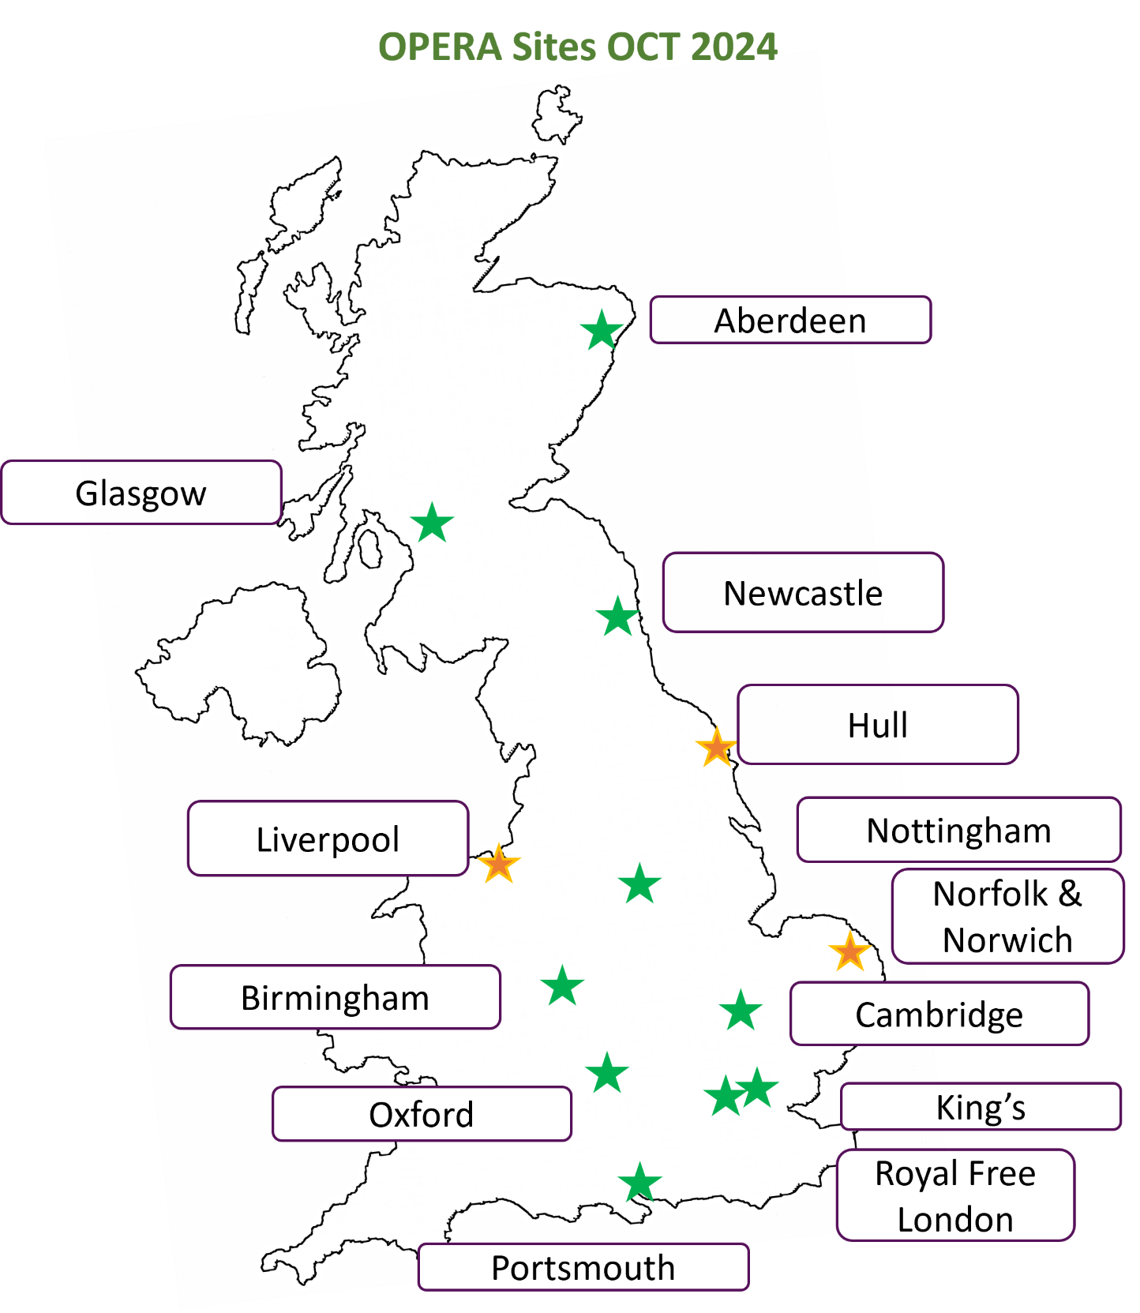
Figure 1. Map of the United Kingdom showing OPERA sites as stars
Sites with a red star have not yet returned feasibility forms
Sites with a blue star have returned the feasibility form and are in set-up
Sites with an orange star have had their SIV
Sites with a green star have the greenlight from sponsor

